Lab – 3 – Bash Scripting
Perform this lab on any LINUX systems terminal with Bash installed.
You can access the command line by running the terminal app. Bash is the default terminal in Ubuntu.
There are numerous Linux commands, and you may find yourself utilizing some more than others. Don't worry if you can't recall the command syntax; neither can I. If you grasp the principles, you can always look up the syntax and relevant examples online. When compared to Windows Batch programming, Bash scripting is one of the easiest forms of scripting to learn. Bash is incredibly versatile and has many sophisticated capabilities that batch scripts do not have.

Part 1: Bash and Bash scripts. (20 marks)

Use a command to check the types of Shells available on your system. The file /etc/shells give an overview of known shells on a Linux system:
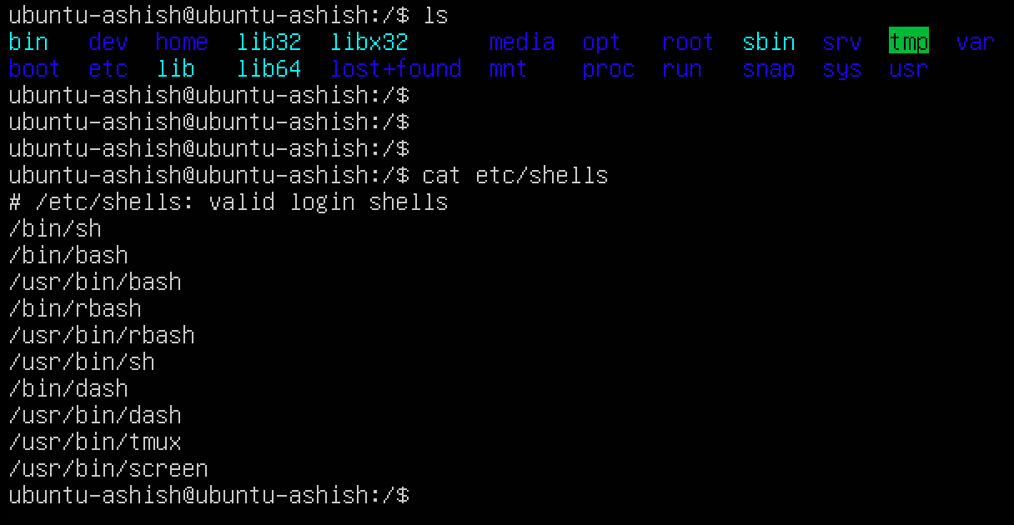

The GNU project (GNU's Not UNIX) provides free software and UNIX-compliant tools for UNIX- like system management.
Bash is a sh-compatible shell that combines features from the Korn shell (KSH) and the C shell (csh). It aims to comply with the IEEE POSIX P1003.2/ISO 9945.2 Shell and Tools standard. It improves on sh in terms of functionality for both programming and interactive use, including command line editing, unlimited size command history, task control, shell functions, and aliases, indexed arrays of limitless size, and integer arithmetic in any base from two to sixty-four. Most sh scripts may be executed without modification by Bash.
The bash effort, like the other GNU initiatives, was founded to maintain, defend, and promote the freedom to use, study, copy, change, and redistribute the software. It is well acknowledged that such circumstances foster creativity. This was also true of the bash program, which has many more functions that other shells do not.

- Where is the bash program located on your system?
- Use the --version option to find out which version you are running. (Add screenshot)
- why command bash_profile is used in Linux?

- Which shell configuration files are read when you log in to your system using the graphical user interface and then opening a terminal window?

- What is the .bashrc file in Linux? (Add screenshot of cat .bashrc)

- What is an interactive shell and login shell?

- Are the following shells interactive shells? Are they login shells?
  - A shell is opened by clicking on the background of your graphical desktop, selecting "Terminal" or such from a menu.
  - A shell that you get after issuing the command ssh localhost.
  - A shell that you get when logging in to the console in text mode.
  - A shell obtained by the command xterm &.
  - A shell opened by the mysystem.sh script.
  - A shell that you get on a remote host, for which you didn't have to give the login and/or password because you use SSH and maybe SSH keys.

- Can you explain why bash does not exit when you type Ctrl+C on the command line?

- Display directory stack content. (Add screenshot)

- Display hash commands for your current shell session. (Add screenshot)
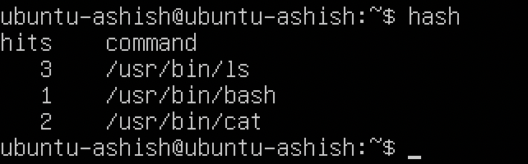
- How many processes are currently running on your system? Use ps and wc, the first line of output of ps is not a process! (Add screenshot)
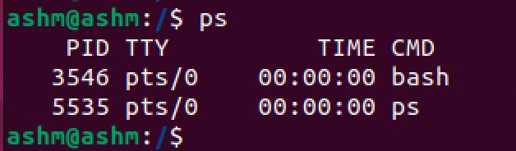
- How to display the system hostname? Only the name, nothing more! (Add screenshot)

- Write down the properties of good scripts.

Part 2: Writing and debugging scripts. (20 marks)
- Write a script using your favorite editor. The script should display the path to your home directory and the terminal type that you are using. Additionally, it shows all the services started up in runlevel 3 on your system.
(Hint: use HOME, TERM and ls /etc/rc3.d/S*) (Add screenshot)
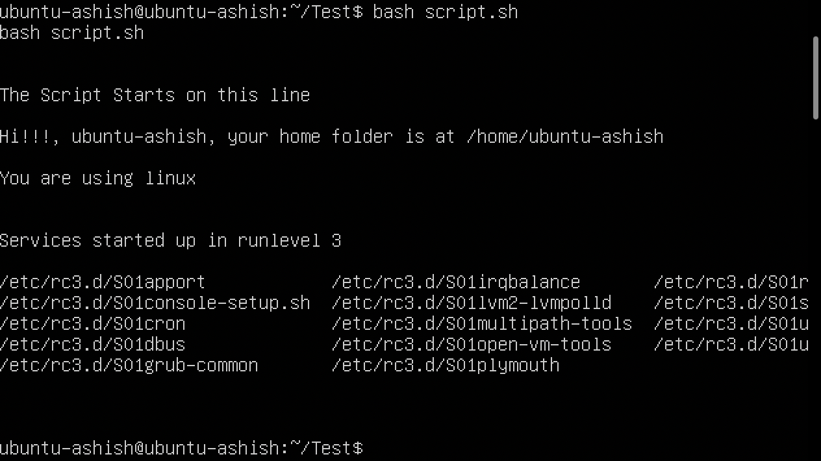

- Add comments in your script. (Add screenshot)

- Add information for the users of your script. (Add screenshot)

- Change permissions on your script so that you can run it. (Add screenshot)
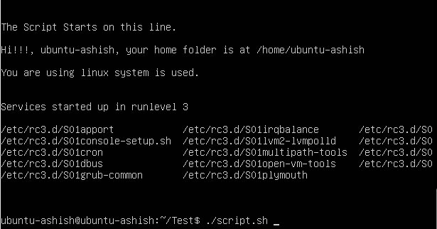

- Run the script in normal mode and debug mode. It should run without errors. (Add screenshot)

- Make errors in your script: see what happens if you misspell commands, if you leave out the first line or put something unintelligible there, or if you misspell shell variable names or write them in lowercase characters after they have been declared in capitals. Check what the debug comments say about this. (Add screenshot)

Part 3: The Bash environment. (25 marks)
For this exercise, you will need to read about the useradd, because we are going to use the /etc/skel directory to hold default shell configuration files, which are copied to the home directory of each newly added user.
First, we will do some general exercises on setting and displaying variables.
- Create 3 variables, VAR1, VAR2, and VAR3; initialize them to hold the values "thirteen", "13" and "Happy Birthday" respectively. (Add screenshot)
Variables are case-sensitive and automatically capitalized. Local variables are occasionally given lowercase names as a convention. You may, however, use any names you wish or mix cases. Variables can also contain numbers, although names that begin with a digit are not permitted:

VARNAME="value"
Errors will occur if spaces are placed around the equal sign. When assigning values to variables, it is a recommended practice to quote content strings to decrease the possibility of mistakes.
- Display the values of all three variables. (Add screenshot)

- Are these local or global variables? Explain in brief.

- Remove VAR3. (Add screenshot)

- Can you see the two remaining variables in a new terminal window? (Add screenshot)

- Edit /etc/profile so that all users are greeted upon login (test this). (Add screenshot)
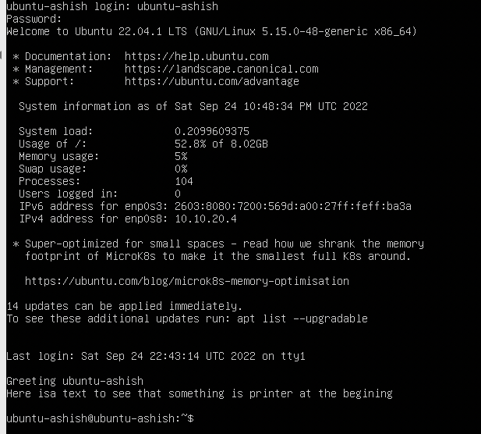
- Write a script in which you assign two integer values to two variables. The script should calculate the surface of a rectangle that has these proportions. It should be aired with comments and generate elegant output. (Add screenshot)

Don't forget to chmod your scripts!

Part 4: Write a bash script. (25 marks) (Add screenshot)
Use an if/then/elif/else construct that prints information about the current month.
The script should print the number of days in this month and give information about leap years for the entered value of the Year as shown in the output below.
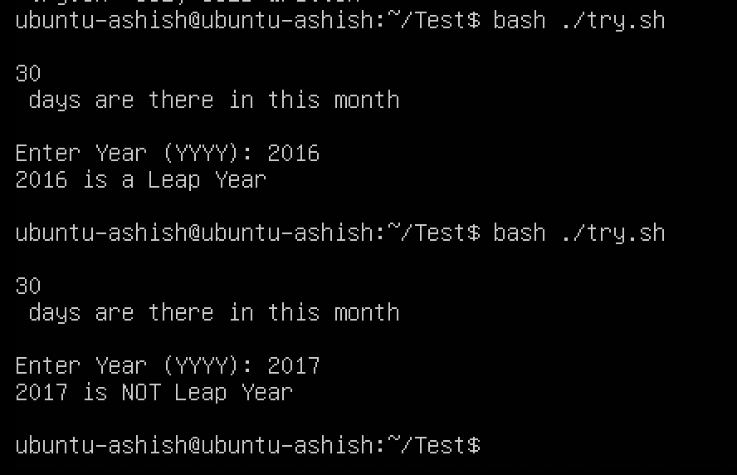

Part 5: Give a brief explanation of the Case statement used in Bash scripting. (10 marks)
Run the following bash script and explain the output. (Add screenshot)
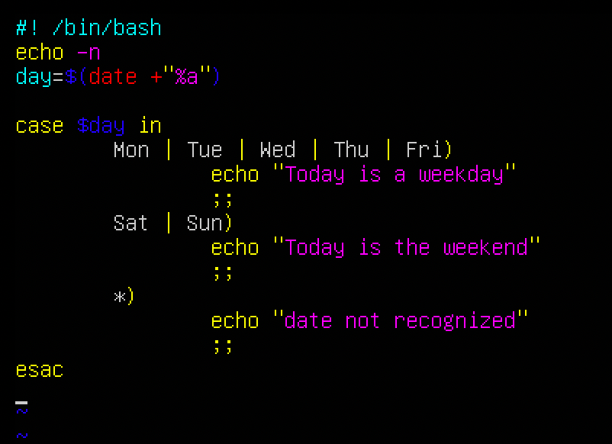
Answer –
End of Lab

